Les Landes Primary School Curriculum Map in Art and Design Skills 2025-6 Long term overview
Drawing (line marking/shape/tone/texture) Painting Printing Textiles 3-D Digital Media Collage
Ongoing in each Year group exploring and developing ideas in sketchbooks, evaluating and developing work by learning from artists.
Year 1  Eric Carle  Peter Knight  Lisa McDonald  Catherine Kadin | Eric Carle – animal mixed media  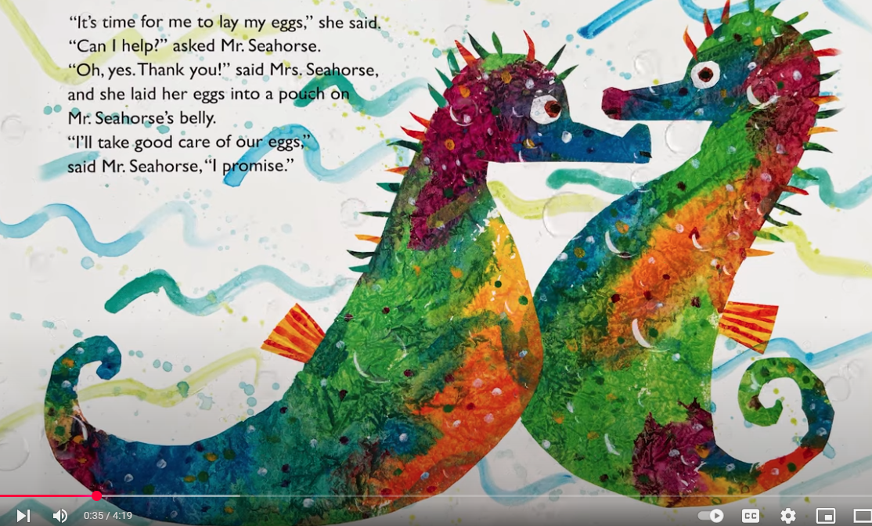  Pastel drawing  warm cool watercolours /poster paint  Tissue/paint/pastel mixed mdia collage  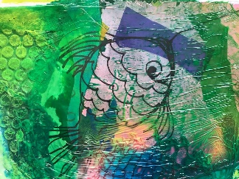  Textiles – printing on to fabric and drawing to add detail | Printmaking – inspired by nature, patterns and the body  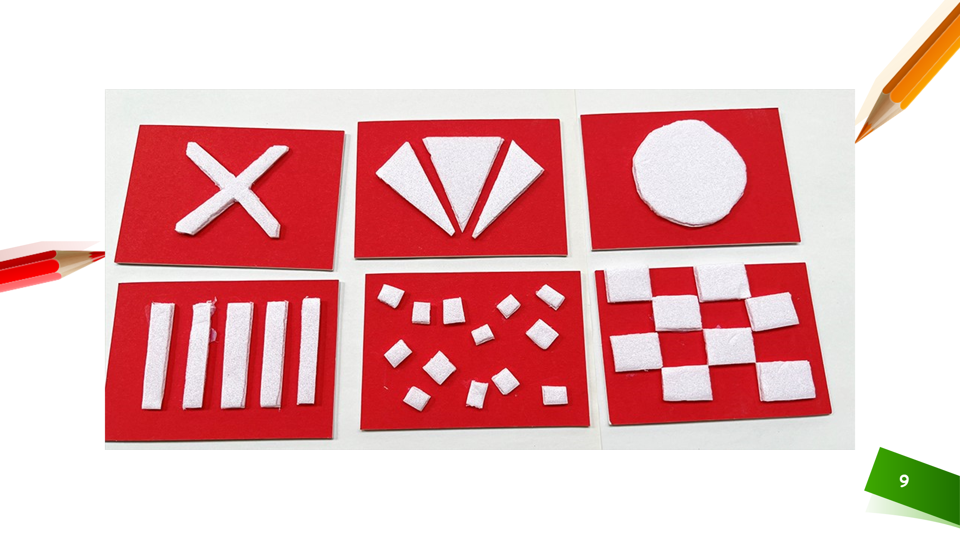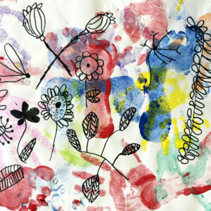  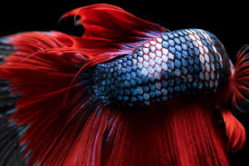  Catherine Kadin  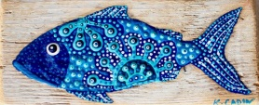  Observational drawing | Peter Knight  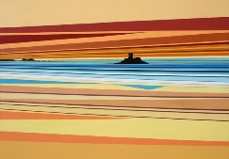  Textiles Weaving map of wonders warm and cool colours landscapes  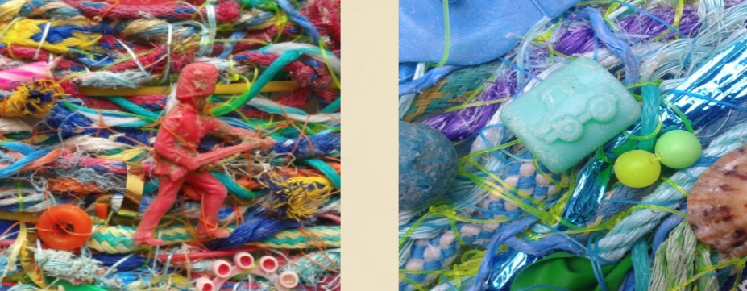  Clay - Owls 3-D – shaping modelling and imprinting. Cutting and Joining clay  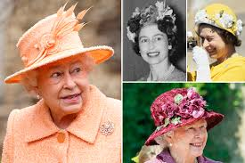  The Queen’s Hat
Year 2  Kandinsky  O’Keefe  Dalaunay  Picasso  Van Gogh  Goldsworthy | 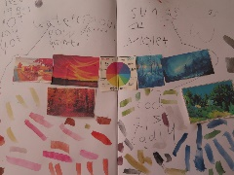  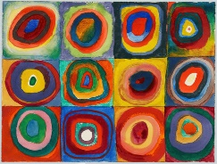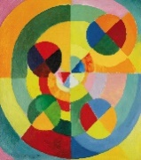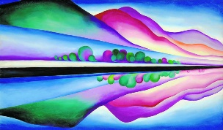  Kandinsky, O’Keefe and Delaunay  Painting and sketching – colour tints/ shades | 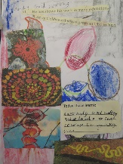  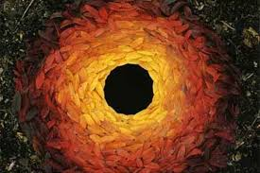  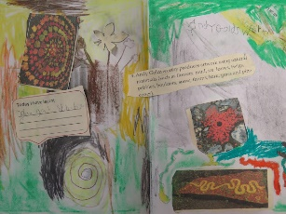  3D Nature sculptures Andy Goldsworthy  Pathway: Stick Transformation Project  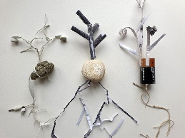  Drawing and modelling  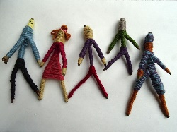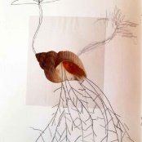  Drawing – Architecture 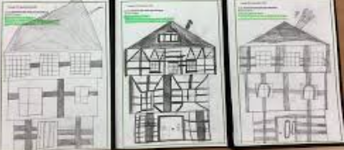 | Picasso/ Van Gogh  Pastel and mixed media collage  Self portraits  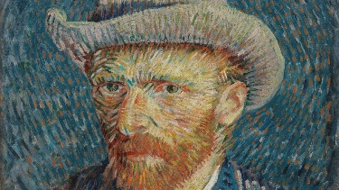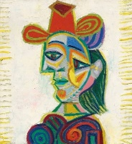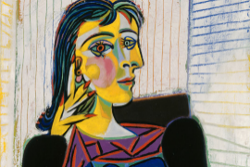  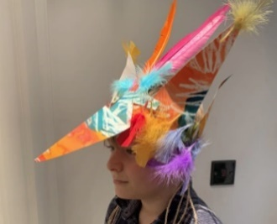  Map or wonders Headdresses Granada day
Year 3  Angie Lewin  Andy Warhol  Darrell Wakelam  Chris Mould | Painting – Andy Warhol  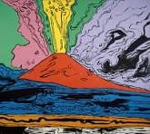  Revise colour circle – complementary and contrasting colours.  Volcano picture – block contrasts Contrasting colours tones and tints – mixing watercolours  Printing - Angie Lewin  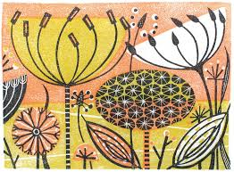  Map of wonders – save the planet cyanotype and Anthotype printing.  Angie Lewin sketchbook work and single block Printing  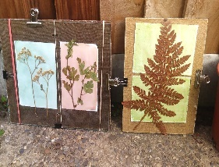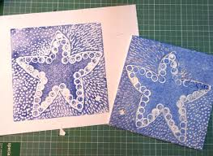  Drawing – Fossils  Pencil drawings sketchbooks – fossils  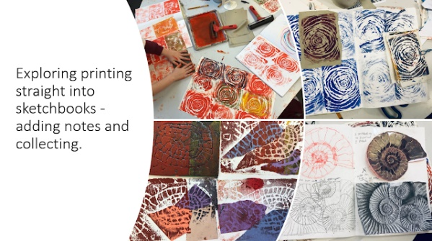 | 3D Modelling Clay  Tudor roses Slab rolling, joining clay Or Pinch-pot mythical monsters for Arthurian legends.  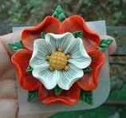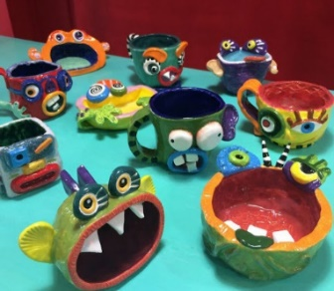  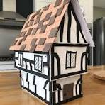  3D Modelling Tudor Houses  Modelling – experimenting with construction and joining recycled materials.  Collage - Tudor portraits.  Pencil sketch – portrait, eye positions, shading, light dark tones.  Collage - Mixed Media (Possibly group not individual) Poster Paint, collage, paper, straw foil etc.  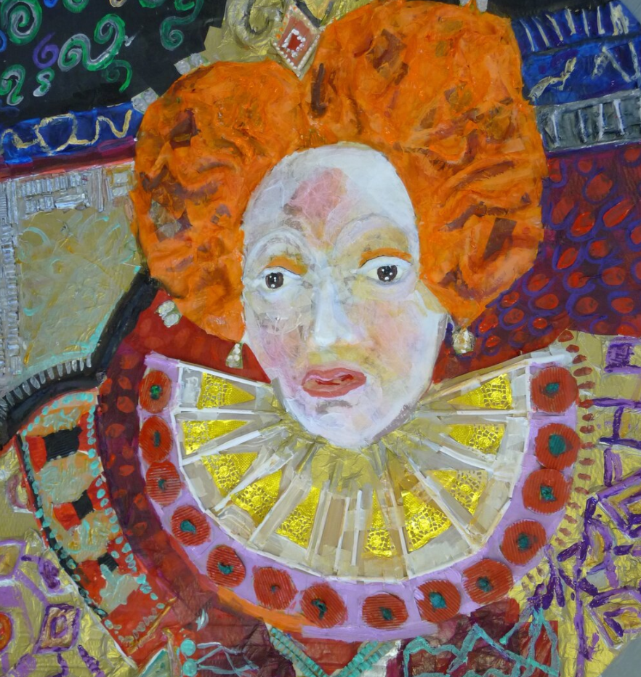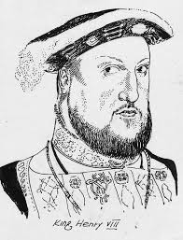 | 3 Modelling - Darrel Wakelam  3-D - Iron Man Model  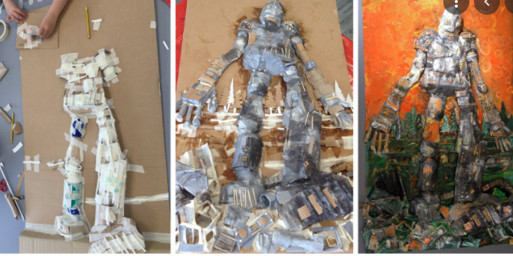  Chris Mould – Illustrator  Drawing – pencil or Pastels – The iron Man  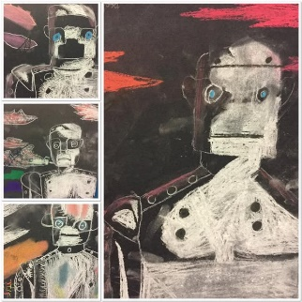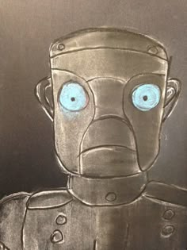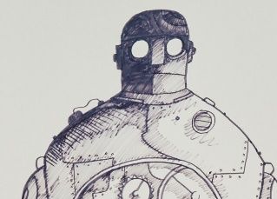
Year 4  Andy Warhol  Andre Margey  Sally Trace | Digital -Andy Warhol – Pop Art  Digital art –  Sketchbook work – drawing labels – exploring fonts etc.  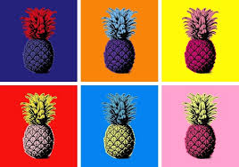  Painting – Mandalas.  Mandalas _ Map of Wonders  Painnting – Watercolours  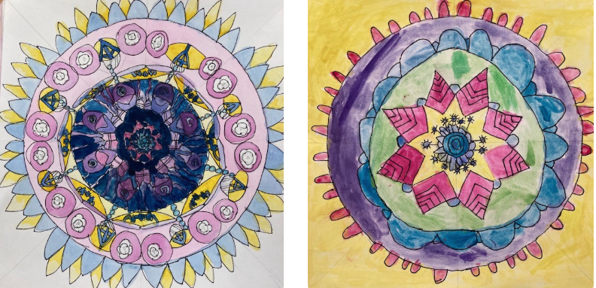 | 3D Modelling Greek Architecture  3D – Architecture  Construction columns and temples.  Sketchbook work experimenting with tone,  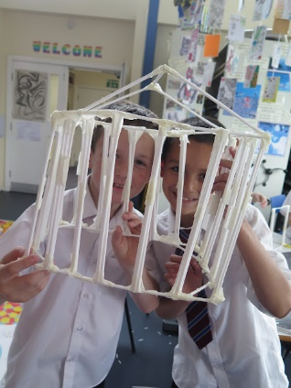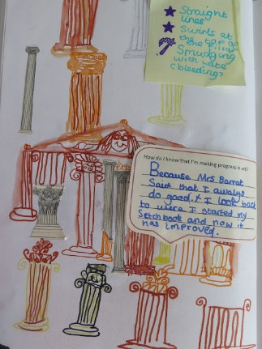  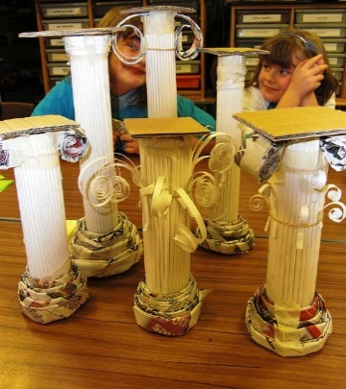 | Painting - Andre Margey /Sally Trace  Coastal painting in style of Andrew Margey  Acrylic Painting – focus blending and colour mixing, directional painting.  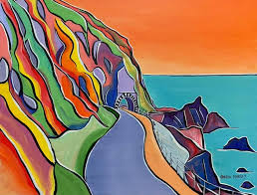  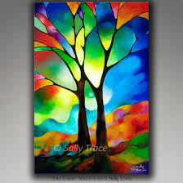
Year 5  L.S. Lowri  William Morris  Karen Tose  Maria Pyrmachenko  Gustav Klimt | 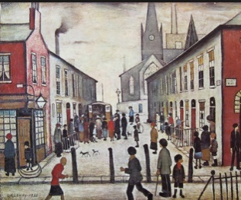  Drawing LS Lowri  Drawing – perspective. Colour and mood  Painting William Morris  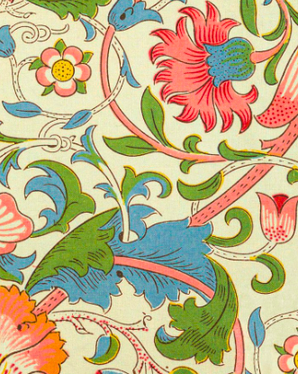  Ink painting based on William Morris  Printing – William Morris  reduction printing  2 layer block printing in style of William Morris  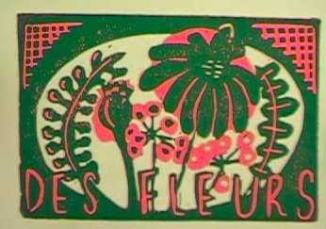 | Textiles – Karen Rose  Batik and embroidery  Batik designed with flour paste resist/ hot wax resist and sewing including different embroidery stitches. .  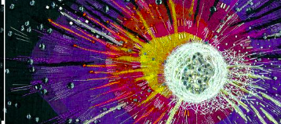  Collage Maria Pyrmachenko  Pastel drawing and watercolour painting  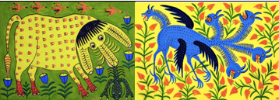 | Collage Gustav Klimt  Klimt stype large Egyptian Gods –  Mixed Media Collage Team activity  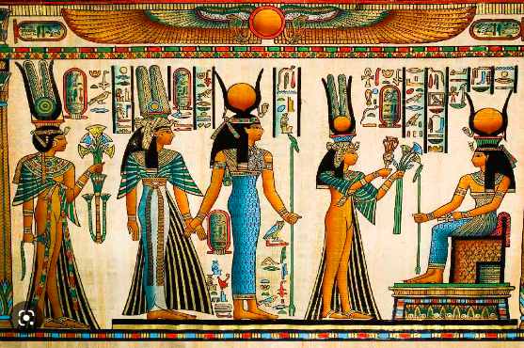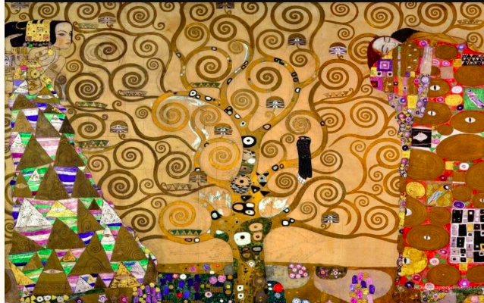  3D Modelling  Egyptians – canopic jars. – clay  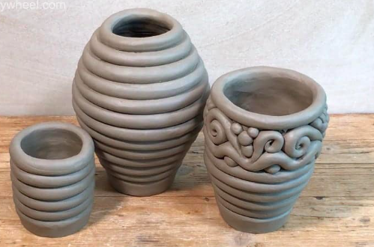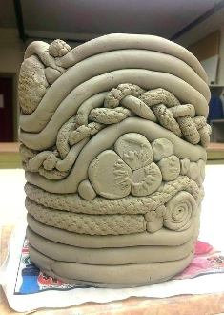  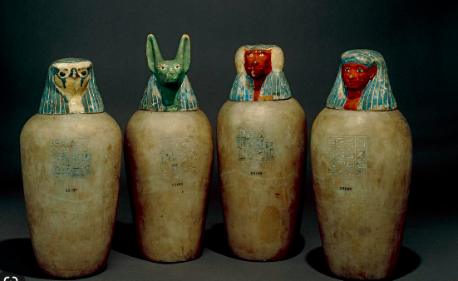  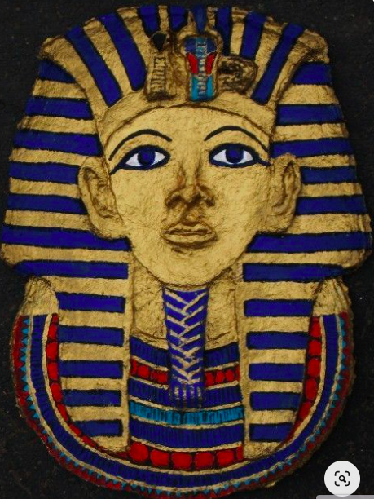  3D Modelling – Darell Wakelam  Card/ modrock
Year 6  Henry Moore  Mike Barrette  Jools Holt  David Hockney | Painting/ Drawing Henry Moore  Drawings and photography  Paintings and pen drawings based on WW2 Art  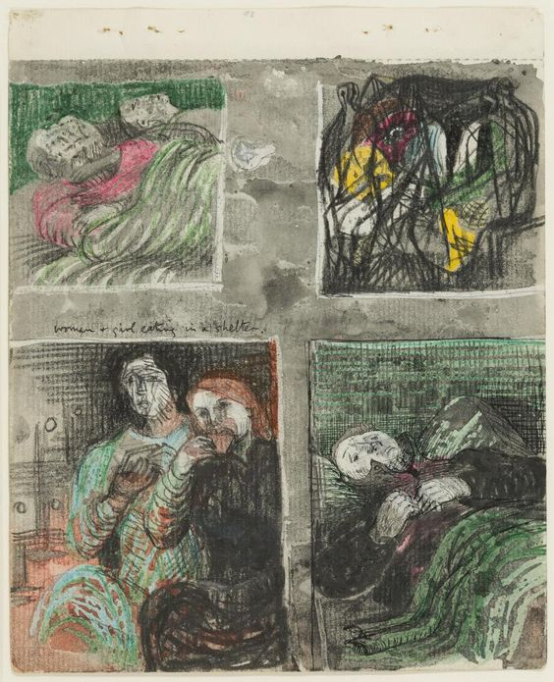  3 D modelling Henry Moore  Sculpture – wire and paper  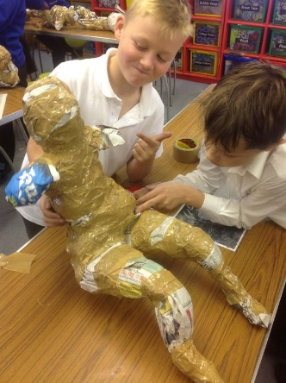 | Digital Art - Mike Barrette Jools Holt  Who am I? What is Jersey  digital media Art Project  Painting for mixed media work  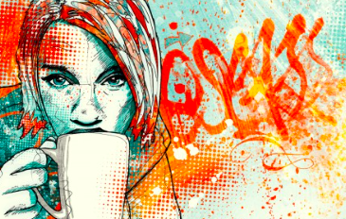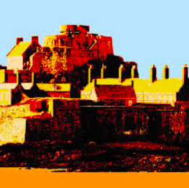  3D Modelling Clay – Fantastic Beasts /Lighthouses  Sketchbook work – drawing eyes – shading, hatching, use of art pencils.  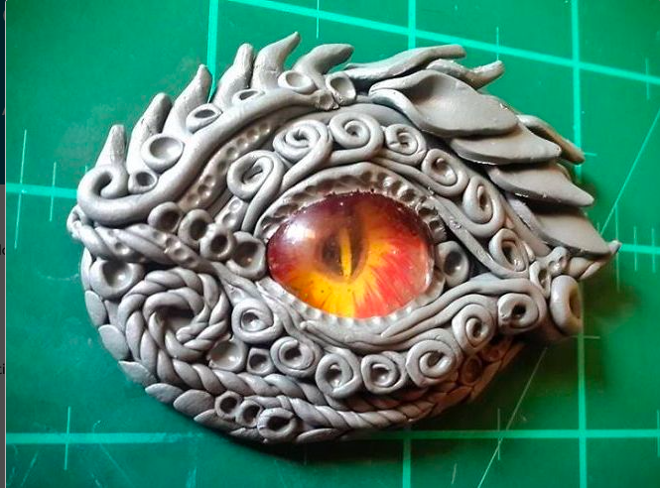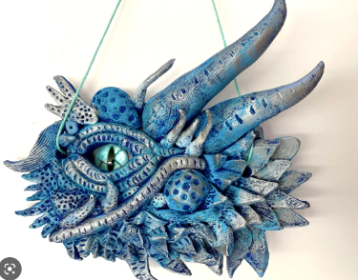  Clay and painting – joining, modelling and imprinting  or – Lighthouses | Evolution Art  Drawing /Painting linked to Science  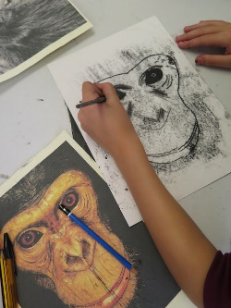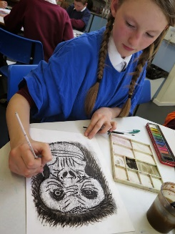  Ian Rolls – Les Landes School  David Hockney  Observational drawing / painting  

