

Medical Conditions and Medicines in School Policy

UNCRC Article 3: Everyone who works with children should do what is best for each child.
UNCRC Article 19: Children should not be harmed and should be looked after and kept safe.
Article 24: Every child has the right to the best possible healthcare.

Introduction
This policy must be seen within the context of the Department for CYPES policy entitled ‘Administration of Medicines in Schools’ which can be accessed via gov.je. Whilst this policy cannot detail every medical condition and subsequent school procedure, we will detail ones relevant at the time of writing and review annually.

All our recording is in line with the CYPES retention schedule.

Legal Framework
-as described within Department for CYPES’s policy – Administration of Medicines in Schools

- Schools are responsible and accountable for the health and safety of pupils in their care.
- The Medicines (Jersey) Law 1995 places restrictions on dealings with medicinal products, including their administration. In the case of prescription-only medicines, anyone administering such a medicinal product by injection must be an appropriate practitioner (e.g. a doctor) or else must act in accordance with the practitioner’s directions.
- There is no legal or contractual duty on school staff to administer medicine. This is a voluntary role. However, swift action would need to be taken by a member of staff to assist any pupil in an emergency.
- School staff in charge of pupils have a ‘common law’ duty to act as any reasonably prudent parent would to make sure that pupils are healthy and safe on school premises and this might, in exceptional circumstance, extend to administering medicine and /or taking action in an emergency.
- This duty also extends to teachers leading activities taking place off the school site, such as educational visits, school outings or field trips. The Education (Jersey) Law 1999 provides scope for teachers to do what is reasonable for the purpose of safeguarding or promoting children’s welfare.
- CYPES fully indemnifies its staff against claims for alleged negligence providing they are acting within the scope of their employment, have been provided with adequate training and are following the CYPES guidelines. For the purposes of indemnity, the administration of medicines falls within this definition and hence staff can be reassured about the protection their employer provides.

Procedures
Some pupils who have an on going medical condition will require regular medication within school hours. Likewise, children are often well enough to come to school but on medication. To lessen the number of absences it seems sensible to accept that any necessary medication is allowed to be brought to school.

For these pupils the following procedures should be undertaken:

- It should be the exception rather than the rule for medicines to be brought into school.
- Medication should only be administered after a written request from parents using the Record of Medication form (appendix 1). Discretion is given to verbal instructions on a case by case basis.
- All medicines must be clearly labelled and given to the school by the parent.
- If the dosage requirement is 3 times daily then the medication should not be accepted at school as the middle dose can be given by the parents after school.
- Medication should be kept in the secure cupboard, located within the First Aid cupboard, in the disabled toilet.
- Potential emergency medication e.g. adrenalin/hypoglaecemia packs or insulin should be kept in an accessible place as described within an Individual Health Care Plan. Such medication must always be taken on off site or residential trips.
- A note of the date, child’s name, medication, dose and time given must be made on SIMS under a ‘Medical Event’. Staff administering medication should report details to the school office / secretary so it can be recorded on SIMS and linked to the pupil record.
- Medicines must be administered by a qualified First-Aider as prescribed and directed by the parent, or as trained by the school nurse team.
- The school is not obliged to administer ‘over the counter’ medication.
- Analgesics, anti-histamines and topical medication should not be provided to pupils by the school, unless in exceptional circumstances and permission is given by parents, but if prescribed can be administered under the same procedures described within this policy.
- A nominated member of staff will ensure that any unused medication is returned to the parents as appropriate.
- Policy and procedures will be communicated to parents through the School Handbook, newsletters and website.
- School will share medical information with third party providers where responsibility is handed to them eg. PGL Activity Centre, Dorset

Responsibilities
The Headteacher is responsible for all medical procedures and medicines in school and for ensuring that the school is compliant with training requirements.
Staff are responsible for acting within the strict guidelines of this policy.
The Headteacher will provide support for staff who manage adverse events.
Parents or guardians are responsible for:
- Making a request in writing for medication to be given;
- Providing medication in its original container clearly labelled with the child’s name, the name of the medication, the dose and time to be given;
- Informing the school in writing of any changes of medication;
- Replenishing or updating the medication; for adrenaline pens, the parent must provide the school with two pens and these must both be in date. It is the responsibility of the parent to check the dates and replenish these.
- Ensuring that medication is taken home at the end of the day if it is needed at home, medication will not be handed to children to take home.
- Ensuring that their child has their inhaler with them at out of school hours sports fixtures;
- Knowing that if they send their child to school without the agreement of the headteacher the school will not be responsible for that medication.

Individual Health Care Plans
Some pupils have medical conditions that, if not properly managed, could limit their access to education or require emergency treatment. Such pupils are regarded as having medical needs. Such pupils will need an Individual Health Care Plan, to ensure their safety and well-being. Such plans should be drawn up in conjunction with parents, the child and the child’s medical carers and should set out in detail the measures needed to support them, including preparing for a medical emergency. All staff should be aware of the details of these plans and information although confidential, should be displayed in staff areas and where easily accessible. Adrenaline pen administration is included in First Aid training for individual members of staff. E learning for diabetes is completed for as many staff as possible. Care Plans are carried by staff for off-site visits and passed to paramedics if ambulance treatment required.
Inhalers
Children who require inhalers for asthma and allergic conditions should keep their inhalers with them. This encourages independence and responsibility of use. Parents should inform the child’s teacher of the need for an inhaler. It may be appropriate for a spare inhaler to be provided for the school. Inhalers are kept in the first aid cupboard within the relevant class to that child. All inhalers should be clearly labelled and regularly checked to ensure that they are in date. It is the parents’ responsibility to provide their child/school with a named and in-date inhaler. Inhalers must always be taken on school trips.
Conditions requiring regular or emergency action
Staff volunteers will be required in some cases to administer regular or emergency medication. They will receive appropriate training and guidance by the relevant health professionals. Children potentially requiring such medication must have an Individual Health Care Plan. If the normal routine for administering treatment breaks down e.g. a trained member of staff is not available, immediate contact with the parent needs to be made to agree alternative arrangements such as the parent attending school to administer the treatment. Such medications may include:
Adrenalin pens eg. Epi-Pens
Children with acute allergies may need an adrenalin injection by means of an adrenalin pen such as an Epi-pen. Training and regular updates will be provided for school staff in managing such needs and administering medication. These must be kept in the first aid cupboard within the relevant classroom for that child and must be taken on any off site visits. (See appendix 3).
Insulin
Children with diabetes must have an Individual Health Care Plan, which is developed alongside parents and specialist nurses. Staff who volunteer to monitor and administer medication i.e. insulin will be provided with training and specific instruction. The school keeps an accurate record of all medication administered, including the dose, time, date and supervising staff. Insulin and hypoglycaemia treatment kits must be taken on all off-site trips.
Residential visits
If a residential visit is planned the procedures laid down above should be followed. As part of the organisation for the trip parents will be asked to provide details of any medication required and to ensure that the trip leader is handed the medication which must be clearly labelled with the child’s name and dosage requirements. Extra medication should be provided in case of a delayed return. Written consent to administer analgesia e.g. Calpol or sea sickness medication if necessary should be sought prior to any residential trip.

Date | 18/10/13
Review dates | 20/11/14
 | 25/11/16
 | 10/5/17
 | 9/11/18
 | 30/1/2020
 | 09/2/2023
 | 17/7/2024

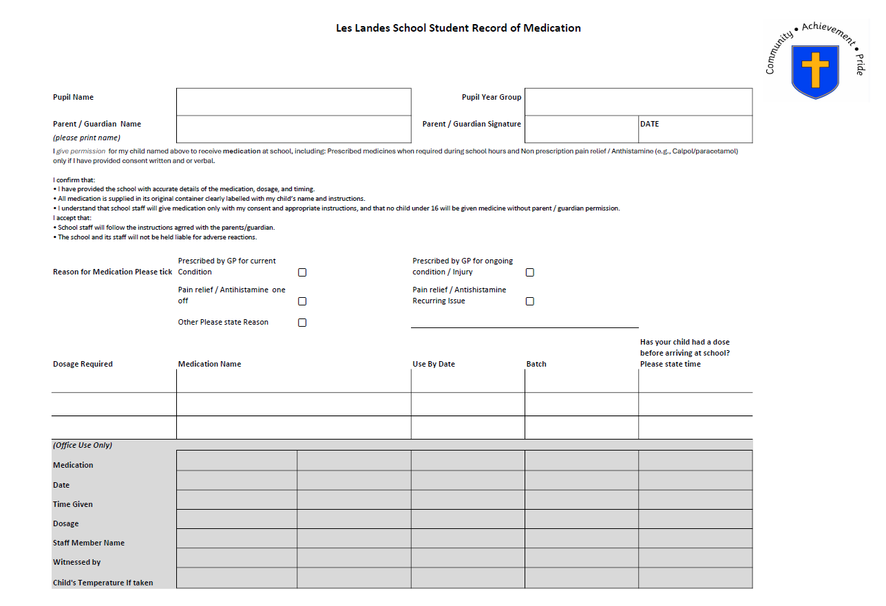
Appendix 1

