
Les Landes School Counter-Bullying Policy
(To be read alongside the CYPES Counter-Bullying Policy 2019)
UNCRC Article 3: Everyone who works with children should do what is best for each child
UNCRC Article 19: Every child has the right to be protected from harm
UNCRC Article 37: Every child has the right to be treated fairly

Policy Statement
Les Landes School is committed to creating a safe, respectful and inclusive environment where bullying is not tolerated. Bullying harms children’s wellbeing, mental health and ability to learn. As a UNICEF Rights Respecting School (Gold Award), we place children’s rights, dignity and voice at the centre of our practice.
Our approach aligns with:
- CYPES Counter-Bullying Policy (2019)
- Jersey Violence Against Women and Girls (VAWG) Strategy
- Jersey All-Ages Mental Health Strategy 2026–2030
- United Nations Convention on the Rights of the Child
We work in partnership with pupils, staff and parents to maintain a culture where everyone feels safe, valued and respected.
Introduction
Bullying is a significant safeguarding and mental health concern. Current research (Anna Freud Centre, Anti-Bullying Alliance 2023, NHS Digital) shows that bullying is strongly linked to anxiety, depression, school avoidance and self-harm. Children who bully others often have unmet emotional needs, social anxieties or vulnerabilities that require support.
Bullying can occur in any year group. We take all concerns seriously and respond promptly, fairly and consistently.

Scope
This policy applies to all pupils, staff, volunteers and visitors. It should be read alongside:
- Safeguarding Policy
- SEND and Inclusion Policy
- Digital Safeguarding Policy
- Positive Behaviour Policy
- Positive Mental Health Policy
Aims
This policy aims to:
- Increase staff understanding of bullying and its impact
- Build staff confidence in responding effectively
- Ensure consistent investigation using open, non-leading questions
- Support all children involved-those harmed, those who have harmed others, and witnesses
- Promote a whole-school culture of respect, kindness and inclusion
Definition of Bullying
We adopt the Anti-Bullying Alliance definition:
Bullying is behaviour that is intentional, repeated, and involves an imbalance of power, causing physical or emotional harm.
Bullying may be emotional or physical, direct or indirect, and may occur between children or adults in any combination.
Les Landes is committed to challenging all forms of bullying, including within the staff team, in line with Government of Jersey policies.
Types and Forms of Bullying
Bullying may include:
Physical – hitting, kicking, damaging belongings
Verbal – insults, threats, name-calling
Emotional – exclusion, humiliation, manipulation
Racist – language or actions based on ethnicity or faith
Sexual – unwanted comments, gestures or contact
Homophobic- biphobic or transphobic
Cyberbullying – online messages, images or posts
Gender-based harm – including behaviours identified in the VAWG Jersey Strategy

Online bullying
Online bullying in primary school often happens through the platforms and devices children commonly use at this age. This may include:
- group messaging apps used by families (e.g., WhatsApp groups managed by parents)
- gaming platforms where children can chat or send messages (e.g., Roblox, Minecraft, Fortnite)
- sharing unkind messages or images through tablets or phones at home
- excluding others from online games or groups
- sending repeated unkind voice notes or emojis
- taking photos or videos without permission
Children may not always recognise these behaviours as bullying, so staff must remain alert to patterns of unkindness or distress linked to online interactions.
Although most online activity happens outside school, we will respond to concerns when:
- the behaviour affects a child’s wellbeing in school
- the behaviour involves pupils from Les Landes
- the behaviour relates to safeguarding, including gender-based harm (VAWG)
- the behaviour impacts friendships, safety or learning
Staff will always consider the online context as part of the investigation and follow the Les Landes Counter-Bullying Flowchart.

Creating a Counter-Bullying Culture
We promote a culture of kindness, respect and inclusion through:
- Rights Respecting School ethos
- PSHE, P4C and assemblies
- School Council and pupil leadership roles
- Anti-Bullying Week
- Mental Health Ambassadors
- Clear expectations: ‘All Different, All Equal motto’
Bystander behaviour
We explicitly teach pupils how to respond safely and appropriately if they witness unkind or harmful behaviour, including knowing when and how to report concerns to a trusted adult.

Vulnerable Groups
Some pupils are at higher risk of bullying, including those with:
- SEND or neurodiversity
- speech, language or communication needs
- mental health needs
- experiences of trauma or care
- perceived differences in race, gender, sexuality or disability
Staff take extra care to monitor and support these pupils.

Reporting and managing allegations
The Les Landes Counter-Bullying Flowchart (Appendix A) outlines the steps staff must follow when a concern about bullying is raised. This ensures that all incidents are handled consistently, fairly and in line with safeguarding expectations. The flowchart guides staff through four key stages: Initial Concern, Investigation, Decision-Making, and Support & Monitoring. All concerns must be investigated. Not all conflict is bullying, but all concerns are taken seriously.

Stage 1: Initial Concern Raised and Immediate Safety Check
A concern may be raised by:
• a pupil
• a parent or carer
• a member of staff
• a witness
• a pattern noticed on behaviour logs
All concerns are taken seriously. Staff respond calmly, listen carefully and avoid making assumptions.
Before gathering information, staff must ensure that all children involved are safe.
If the concern involves gender-based harm, coercion, control or sexual harassment, staff must treat this as a safeguarding concern and escalate immediately to the DSL or Deputy DSL. Where behaviour reflects gender stereotypes or exclusion (e.g. “girls can’t play”), staff should challenge the behaviour and monitor for any emerging patterns.

Stage 2: Investigation- Listen, Reassure and Gather Facts
Investigation Process
Bullying concerns are investigated by trained safeguarding and pastoral staff. An investigation is usually led by:
• Pastoral Lead (DDSL)
• Counter‑Bullying Lead
• Mental Health Lead
• Headteacher (DSL)
• Deputy Headteacher (SENCo and DDSL)
Staff use open, non‑leading questions and speak to a range of children, not only those named. Notes are recorded factually and objectively. Online contexts are considered where relevant.
Stage 3: Assess the Situation — Is This Bullying?
Using the flow‑chart, staff decide whether the behaviour meets the definition of bullying:
• Is it intentional?
• Is it repeated or likely to be repeated?
• Is there an imbalance of power?
• Has harm occurred (emotional or physical)?
If yes, the incident is recorded as bullying on SIMS and the Counter‑Bullying Lead is informed. If no, the behaviour is still addressed where necessary, but recorded under a different category (e.g. conflict, unkindness, behaviour incident).

Where safeguarding concerns arise, staff follow the Safeguarding Policy immediately.
If risk increases at any stage, staff must escalate immediately to the DSL or Deputy DSL.

Stage 4: Communication With Parents and Carers
If the behaviour does not meet the definition of bullying, the parents or carers of the child who raised the concern are informed. The behaviour is addressed appropriately and recorded on SIMS under the relevant category (e.g. conflict, unkindness, behaviour incident).
If the behaviour meets the definition of bullying, parents and carers of all children involved are informed.
Meetings are then arranged to:
- share findings
- agree next steps
- outline support plans
- discuss monitoring arrangements
All communication is recorded on SIMS. The behaviour is logged as bullying.

Stage 5: Support All Children
Support is provided for:
The child who has harmed others
Emotional Profile Questionnaire (EPQ)
If bullying is confirmed, the pupil who has harmed others may complete an Emotional Profile Questionnaire (EPQ) with the Mental Health Lead, SENCo or Pastoral Lead.
The EPQ helps identify underlying needs in five areas:
• Conduct – self‑perception of behaviour
• Worry – anxiety‑driven behaviour
• Negative Peer Relationships – social insecurity
• Anti‑Social Thinking – empathy and responsibility
• Emotional Vulnerability – immaturity, denial, need for control
The EPQ informs a personalised support plan.

Targeted support is based on EPQ findings and may include:
• emotional regulation work
• social skills groups
• pastoral mentoring
• ELSA
• PMHW or counsellor involvement
• restorative meetings
• clear boundaries and behaviour expectations
• increased supervision if needed

The child who has been harmed
• reassurance and emotional support
• safe‑adult check‑ins
• restorative conversations (if appropriate)
• ELSA or pastoral support
• increased supervision if needed

Peers
• revisit class charter
• restorative group-work
• ongoing engagement with the My Happy Mind PSHE programme and strategies
• guidance on safe bystander behaviour
• signposting to trusted adults

Stage 6: Regular Check‑ins
Follow‑up check‑ins (for example, after one week and one month) are arranged where appropriate to ensure support plans are effective and behaviour has improved. These check‑ins are recorded on SIMS.

Monitoring and Review
SLT, SENCo, the Counter‑Bullying Lead and the Pastoral Lead monitor:
• behaviour logs
• patterns of concern
• the impact of support
• whether behaviour has changed
Follow‑up meetings may be held with pupils and parents. If bullying continues, the response escalates in line with the flow‑chart.

Reviewed: June 2026 by Miss C McMenamin.
Next review date: June 2027

Appendix A
Les Landes Counter Bullying Flow-chart
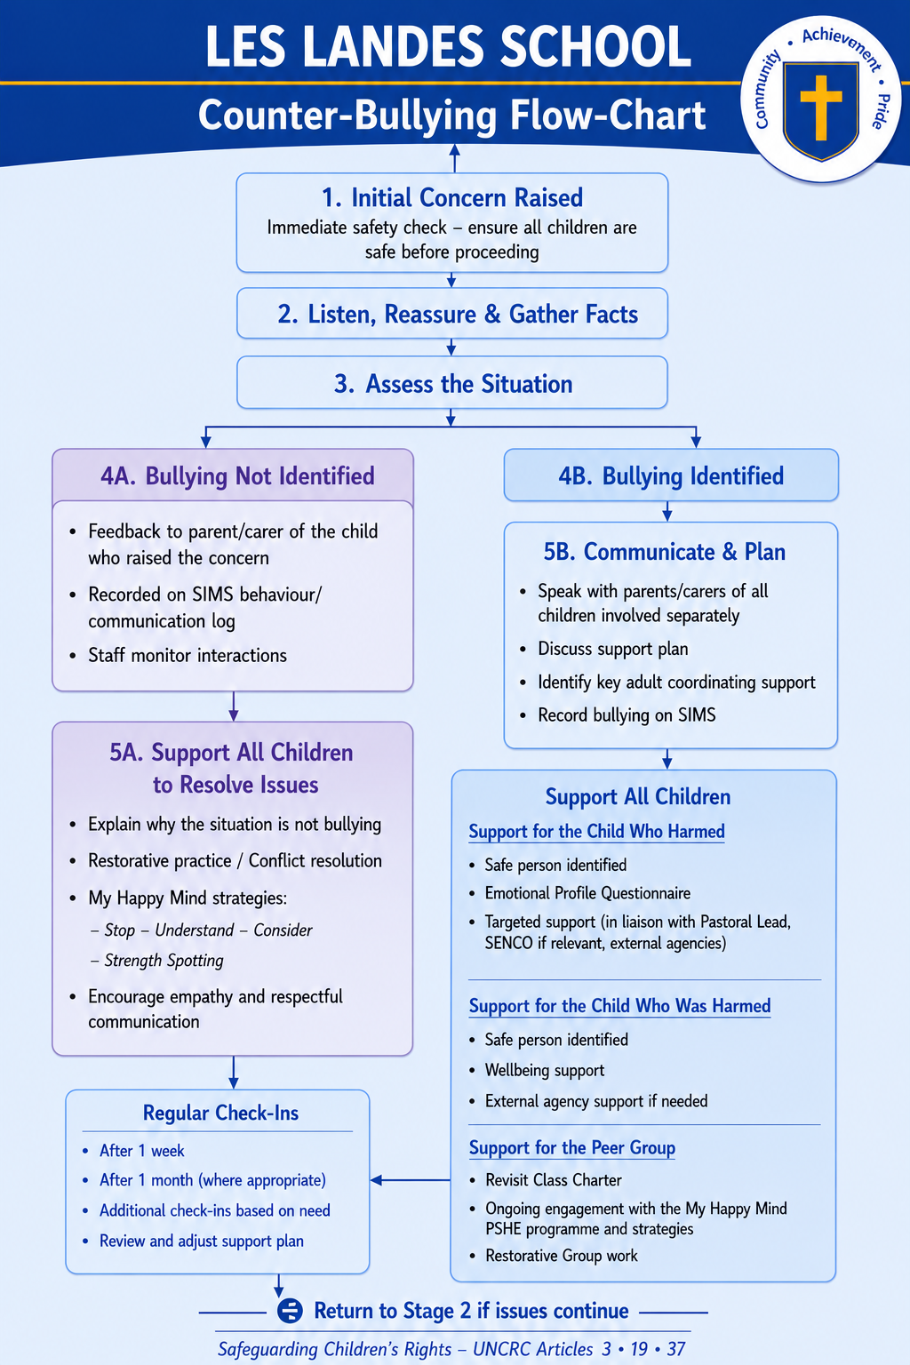
Appendix B
Suggested Non-Leading, Open Questions for Investigating Bullying Concerns
This quick-reference guide supports staff to gather information in a neutral, non-leading and safeguarding-appropriate way. These questions help build an accurate picture of class dynamics, peer relationships and any emerging concerns.
Staff should select the questions that best fit the child’s age, communication style and the context of the concern. T

1. Understanding the General Climate
- Use these questions to explore the overall atmosphere without implying wrongdoing.
- How are things feeling in your class at the moment?
- What’s playtime like for most children right now?
- How do people usually get along in your class?
- Are there any times of day that feel easier or harder for children?
2. Exploring Fairness and Treatment
- These questions help identify patterns of exclusion, unkindness or power imbalance.
- Do you think everyone is treated fairly in your class?
- Are there children who sometimes get left out or find things harder socially?
- Have you noticed anyone being spoken to in a way that didn’t feel kind?
- Are there any groups of children who don’t always get on well?
3. Safety and Belonging
These questions help identify children who may feel unsafe, isolated or vulnerable.
- Who do you feel most comfortable being around at playtime?
- Are there places in school where children feel less safe or confident?
- If someone was feeling worried at school, who might they go to?
- Do you think everyone feels they belong in your class?

4. Identifying Patterns Without Suggesting Blame
These questions allow children to talk about what they’ve seen rather than what they’ve done.
- Have you noticed any children who don’t seem as happy lately?
- Are there times when children don’t get on as well?
- What happens when someone is unkind — how do others respond?
- If someone was having a difficult time with friends, what might that look like?
5. For Children Who May Have Harmed Others (Non-Accusatory)
These questions help understand the child’s perspective without confrontation or blame.
- How have things been going for you with friends lately?
- Are there times when friendships feel tricky or confusing?
- What helps you feel calm or in control when things get stressful?
- What do you think would help things feel better for everyone involved?

6. Guidance for Staff
- Keep questions open, neutral and non-leading.
- Avoid naming children unless the pupil volunteers information.
- Record responses factually, without interpretation.
- Speak to a range of children, not only those named.
- Follow the Les Landes Counter-Bullying Flowchart for next steps.
- Escalate immediately if there is any indication of gender-based harm, coercion, sexual harassment, or safeguarding risk.

